Mini Lesson: Hand Map (p. 70-72)
See Allison's Example (Hand Map)

Hook:
Read aloud the personal narrative named ‘Jabari Jumps’ by Gaia Cornwall. This book evokes a lot of emotions from personal experiences. This book works well for all elementary grade levels (Kindergarten through 5th) grade. Students can easily name Jabari’s emotions and/ or character traits that are revealed through his dialogue and actions. With younger elementary (K-3), teachers should focus on emotions. With upper elementary, teachers should focus on character traits that Jabari possesses.
Mentor Text Examples:
- Overconfident: ““Looks easy” Jabari said”
- Uneasy: ““This ladder is very tall”, he thought. “Are you okay?” called his dad. “I’m just a little tired,” said Jabari. “Maybe you should climb down and take a tiny rest,” said his dad. A tiny rest sounded like a good idea.”
- Scared: “It’s okay to feel a little scared,” said his dad. “Sometimes, if I feel a little scared, I take a deep breath and tell myself I am ready.”
- Hesitant: “His toes curled around the rough edge”
- Confident: “He took a deep breath and spread his arms and bent his knees. Then he sprang up! Up off the board! Flying!”
- Happy: “I did it!” Said Jabari, “I’m a great jumper!”

Purpose:
Think about what you just listened to in Jabari Jumps. What was Jabari feeling at the beginning of the story when he saw other students jump off the diving board? How did he feel as the story progressed? Did his feelings change? How did Jabari feel when he started to make excuses during his attempt to jump? What was he feeling at the end of the book? [List the emotions on the board as students name them.] Can you see how much of this story depends on the emotions of the main character and how they change during the telling of it? When we are trying to write about specific topics, sometimes it is easier to find an important topic – something you really want to write about – if you start with an emotion. Today I am going to model how to use an emotion hand map to find a specific topic.

Brainstorm:
Think about this personal narrative we just read. How do you think the characters were feeling at the beginning of the story? How do you think he felt once he saw other children jumping off the diving board? How do you think he felt when he started to climb up the diving board? How do you think he felt when his dad comforted him? Did his feelings change throughout the story? (The emotions will be written down and displayed on the projector as students respond.) Now class, after discussing these emotions Jabari faced, can you see how much this story depends on the emotions of the characters and how they change during the telling of it? When we are trying to write about specific topics, sometimes it's easier to find an important topic- something you really want to write about- if you start with an emotion. Today I am going to model how to use an emotion hand map to find a specific topic to write about!

Model:
Model your own hand map with your students (see model below). Start with basic emotions such as fear, nervousness, confidence, happiness, and eagerness. Trace your hand on the board or chart paper with fingers spread wide and write one emotion on one finger. From each finger, extend lines to connect to examples of times you felt that way. Try to think of at least two examples for each emotion. Tell students to think of at least 2-3 stories for each emotion. It is okay for them to concentrate on one finger/ emotion at a time. Hand maps are writers’ tools like thesaurus and dictionaries. They should be used to add ideas or use an idea to explore a writing topic. Finally, choose one example from your emotion hand map and model writing a small moment notebook entry in your notebook.

Modeled Hand Map Notebook Entry:
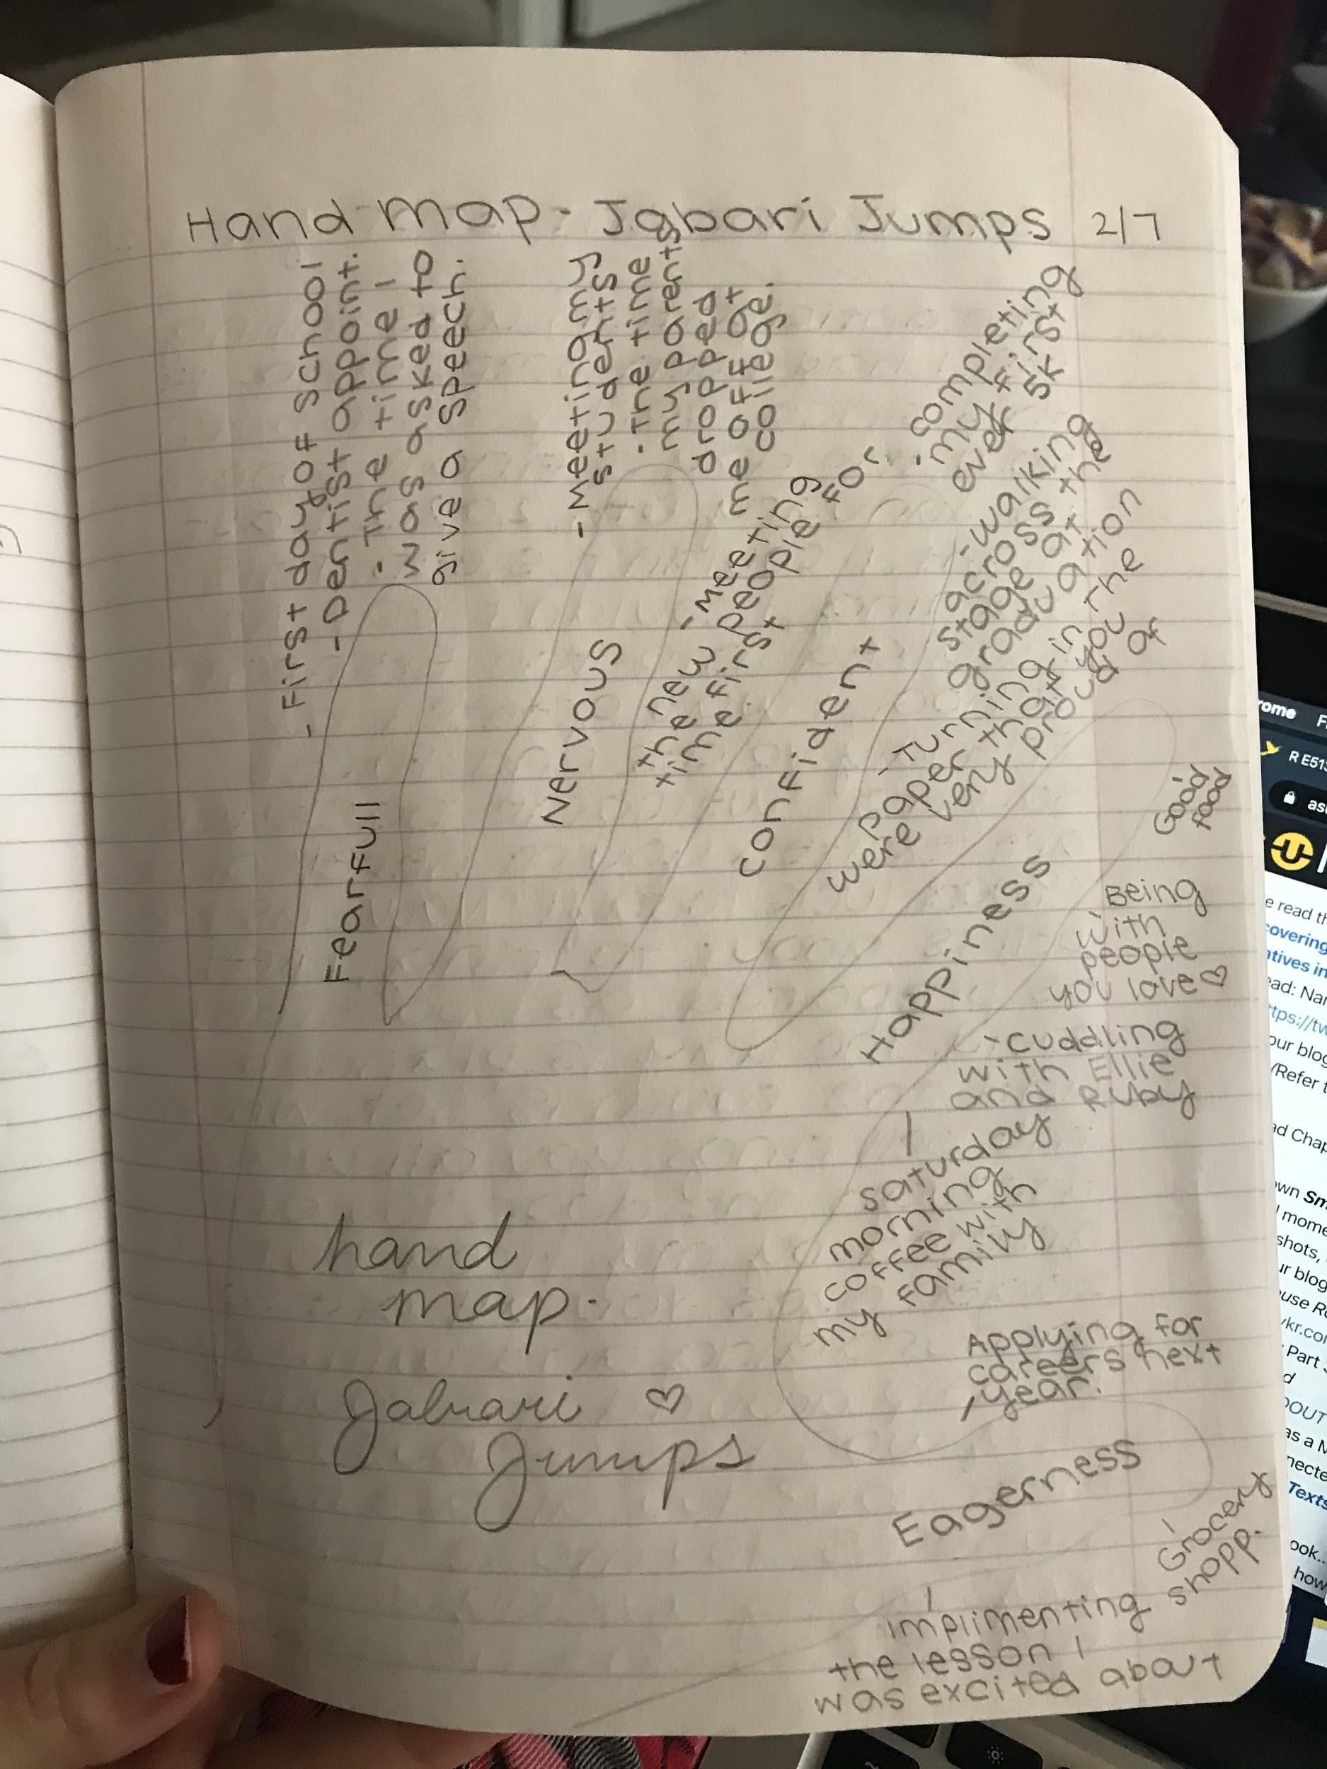
(Abby’s Model)
Modeled Notebook Entry:
(Abby’s Model)“The anticipation was killing me. I had been preparing for this since early October. Now, the day is finally here. It’s January 6th, 2020. Last night, I couldn’t sleep. This morning, I couldn’t eat. As I walked into the elementary school, I was greeted by friendly voices and faces saying “Welcome back! We are excited you are here!” and “Good luck today!” Now, as the bell is about to ring, I feel as prepared as I possibly could. The day is planned and the room is all set. When the bell rings, you walk through the door. You are greeted by my tired but eager eyes. You all are so encouraging and willing to help around the room. Why was I so nervous to meet you? You all are my students. You make the days go by quickly. With fun stories and happy faces. Maybe you knew that I was nervous. Or maybe you were just as nervous as me?”
Shared/ Guided Writing:
Direct students to trace their hand with fingers spread in their writer’s notebook but leave it blank. Model with students and create a “whole group” hand map, choosing from the list of emotions in their notebooks and volunteering examples/ ideas of vivid memories experiencing or associated with that emotion, stated as complete thoughts. Teachers should not force a student to share if they do not want to. Teacher writes their ideas on the whole group hand map.
It is important to insist that students work in phrases or complete sentences when making the group hand map so that they do this when they create their own hand maps.
Examples:
Scared – When all of the power went out in the big storm!
Joyful – School was canceled because of a snow day and we sled all day!
Nervous – Tryouts for the talent show.
While students are creating the group hand map, they should have their own hand maps in front of them. If they hear a good example for an emotion that applies to them that they might not have written in their own list, they can add it to their map. After a collaborative hand map is created and you feel students have a grasp on the strategy, have them get into small groups to work on their own hand maps. Continue to have students work on hand maps and share in small groups while you circulate around the room to observe, ask questions, and offer suggestions.
Teachers should monitor understanding by asking questions like…
- Why did (this experience) make you feel this way?
- Oh wow! That sounds like a (feeling) time. Tell me more about this...

Independent Writing:
Have students pick one example from their hand map and write a short entry about it in their writer’s notebook. Students should return to their hand map and choose a new example if the one they originally chose doesn’t work. As students are working, teachers should work on their own hand maps for the next several sessions. The teacher should be modeling this in front of the room for students to see. If the teacher does not finish in one sitting, they should show the students that the maps should be reviewed and added to throughout the year.
Students and teachers can create more than one hand map over time, especially to try out different emotions and character traits.

Reflection:
A few weeks after introducing hand maps, have students examine their writer’s notebook entries to find examples that started with seeds of ideas from their hand maps. Did they use hand maps without the direction of the teacher? Do they find it beneficial? A few months after introducing hand maps, students examine their writer’s notebook entries and published pieces to find their works that started from their hand maps. Have students reflect on the following questions:

How effective is your hand map as a tool for finding a specific writing topic? What kinds of writing seem to spring from your hand maps?
Would you use a hand map independently?

